Shift-left Logic (sll)

We modified the datapath for the SLL instruction, adding an input line to the ALU with the "shamt" field in order to determine the shift amount. The ALU will identify the SLL operation by the ALUControl field.

**Modified Datapath :**

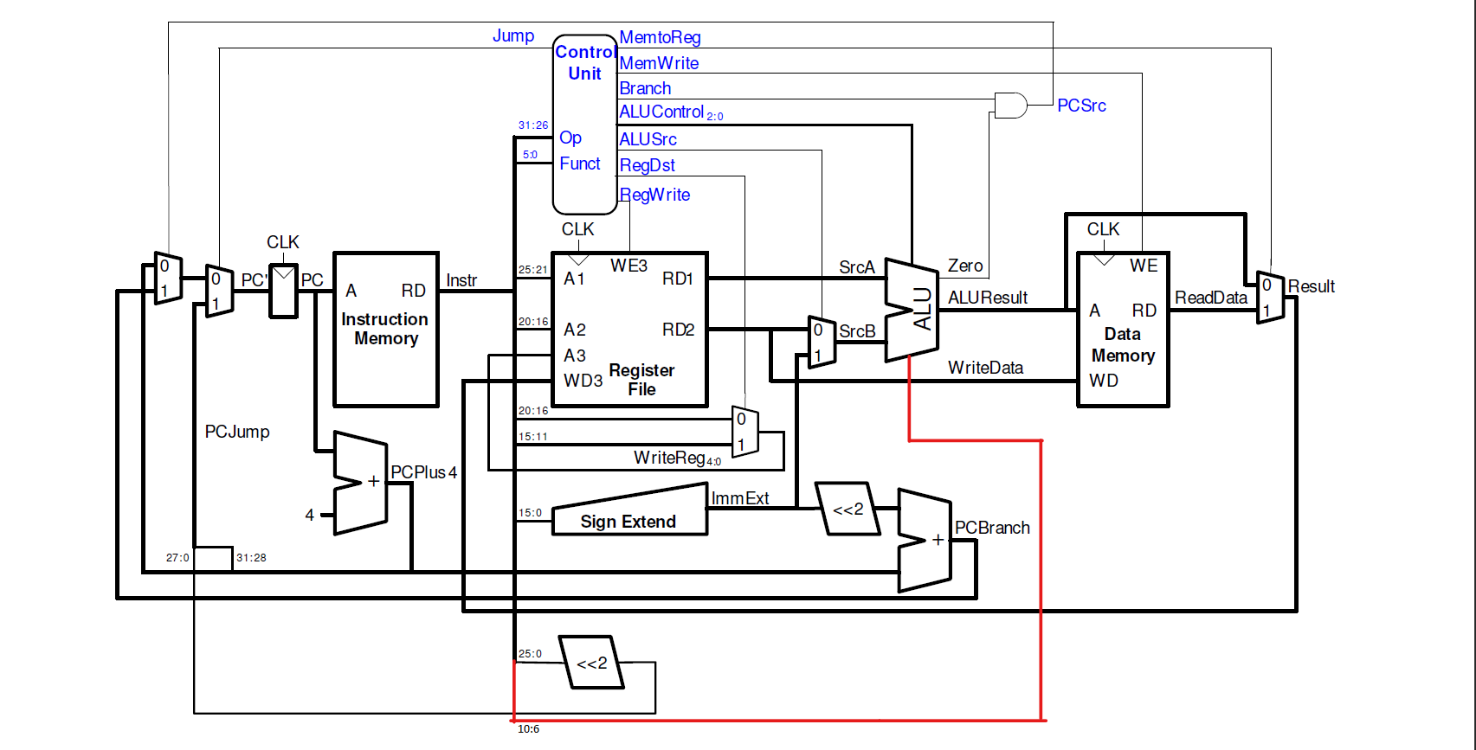

**Control**

|  |  |  |  |  |  |  |  |
| --- | --- | --- | --- | --- | --- | --- | --- |
| Jump | MemtoReg | MemWrite | Branch | AluControl | AluSrc | RegDst | RegWrite |
| 0 | 0 | 0 | 0 | 011 | 0 | 1 | 1 |

Changes made to the ALU:

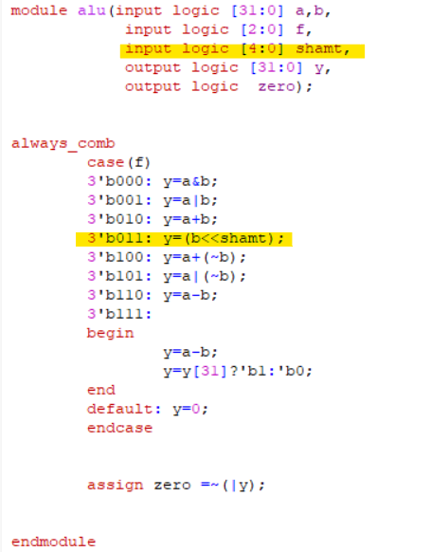

Changes to the ALU Decoder:

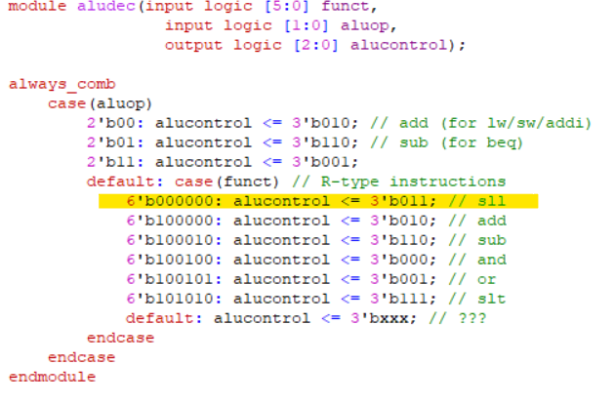



sll instruction is R-type so the format of it’s machine code is

opcode rs rt rd shamt func

000000 00000 &rt &rd shift_amount 000000

6bit 5bit 5bit 5bit 5bit 6bit